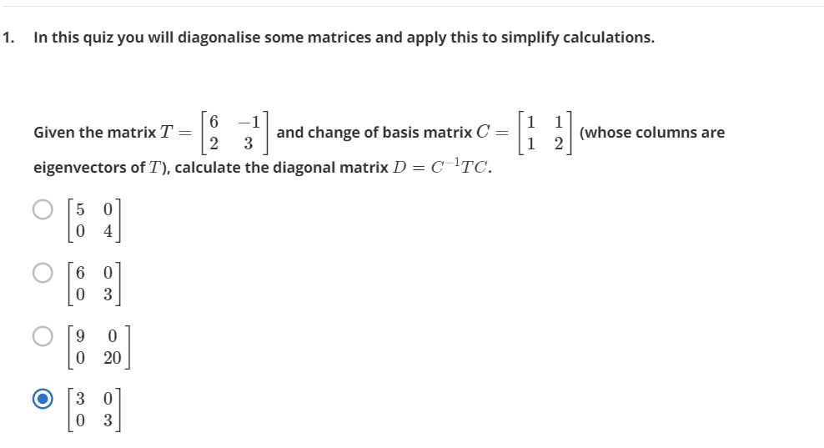

Answer:

Creating Eigen vectors for T

Det(T-Λ) = Det $\left[\begin{matrix}6-Λ & -1 \\ 2 & 3-Λ\end{matrix}\right]$ = 0

(6- Λ)\*( 3- Λ) + 2 = 0

18 - 9Λ + Λˆ2 + 2= 0

Λˆ2 - 9Λ + 20 = 0

(Λ-5) \* (Λ-4) = 0

Substituting Λ1=5 in T,

$$\left[\begin{matrix}1 & -1 \\ 2 & -2\end{matrix}\right] \left[\begin{matrix}X1 \\ X2\end{matrix}\right]= \left[\begin{matrix}X1-X2 \\ 2X1-2X2\end{matrix}\right]=0$$

Which implies, X1 = X2, Hence Eigen value Λ=5 is for Eigen vector $\left[\begin{matrix}1 \\ 1\end{matrix}\right]$

The other Eigen value is Λ2=4.

Answer is $\left[\begin{matrix}5 & 0 \\ 0 & 4\end{matrix}\right]$

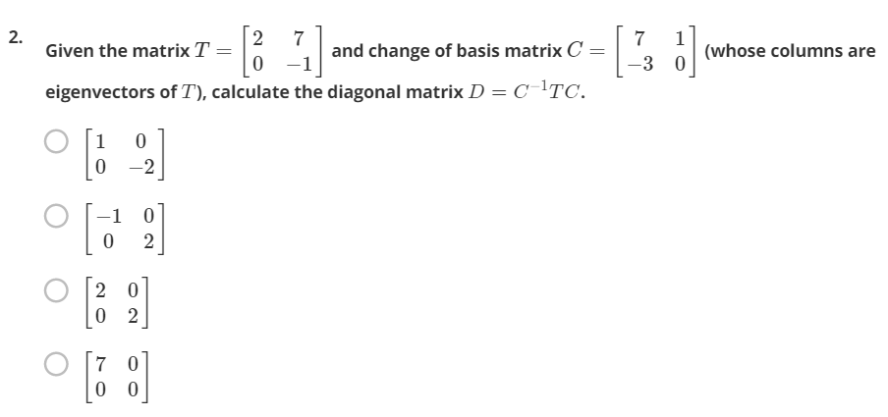

We need Eigen values for Eigen Basis vectors $\left[\begin{matrix}7 & 1 \\ -3 & 0\end{matrix}\right]$

Det(T-Λ) = Det $\left[\begin{matrix}2-Λ & 7 \\ 0 & -1-Λ\end{matrix}\right]$ = 0

(2- Λ)\*( -1- Λ) + 0 = 0

(2 - Λ) \* (-1 - Λ) = 0

Substituting Λ1 = 2 in T,

$$\left[\begin{matrix}0 & 7 \\ 0 & -3\end{matrix}\right] \left[\begin{matrix}X1 \\ X2\end{matrix}\right]= \left[\begin{matrix}7X2 \\ -3X2\end{matrix}\right]=0$$

Which implies, X2 = 0, Hence Eigen value Λ1 = 2 is for Eigen vector $\left[\begin{matrix}1 \\ 0\end{matrix}\right]$

The other Eigen value is Λ2 = -1.

Answer is $\left[\begin{matrix}Λ2 & 0 \\ 0 & Λ1\end{matrix}\right]$ = $\left[\begin{matrix}-1 & 0 \\ 0 & 2\end{matrix}\right]$

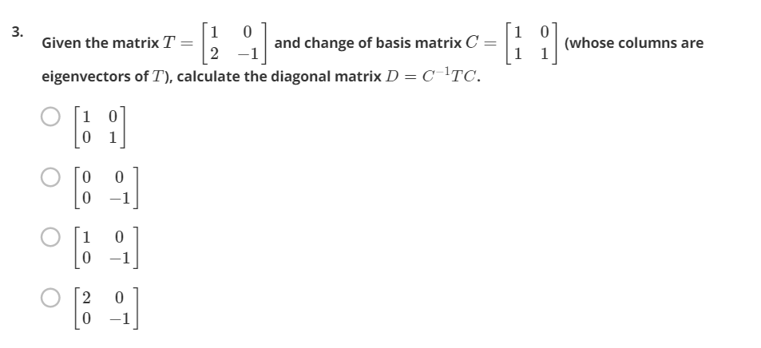

We need Eigen values for Eigen Basis vectors $\left[\begin{matrix}1 & 0 \\ 1 & 1\end{matrix}\right]$

Det(T-Λ) = Det $\left[\begin{matrix}1-Λ & 0 \\ 2 & -1-Λ\end{matrix}\right]$ = 0

(1- Λ) \* ( -1- Λ) + 0 = 0

(1 - Λ) \* (-1 - Λ) = 0

Substituting Λ1 = 1 in T,

$$\left[\begin{matrix}0 & 0 \\ 2 & -2\end{matrix}\right] \left[\begin{matrix}X1 \\ X2\end{matrix}\right]= \left[\begin{matrix}0 \\ 2X1-2X2\end{matrix}\right]=0$$

Which implies, X1 = X2, Hence Eigen value Λ1 = 1 is for Eigen vector $\left[\begin{matrix}1 \\ 1\end{matrix}\right]$

The other Eigen value is Λ2 = -1.

Answer is =

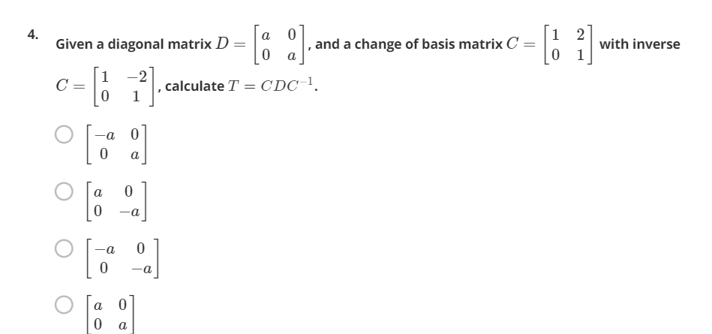

T = CDC­-1 =

=

= aCC­-1 = aI = a

Answer is

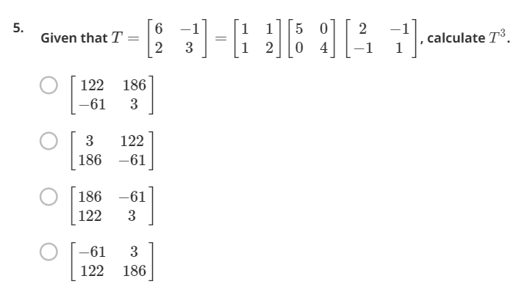

T = CDC­-1

T3 = CD3C­-1 =

=

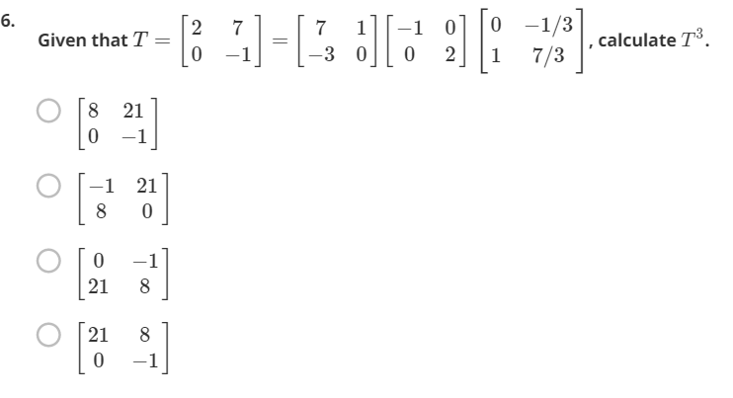

T3 = CD3C-1 =

= 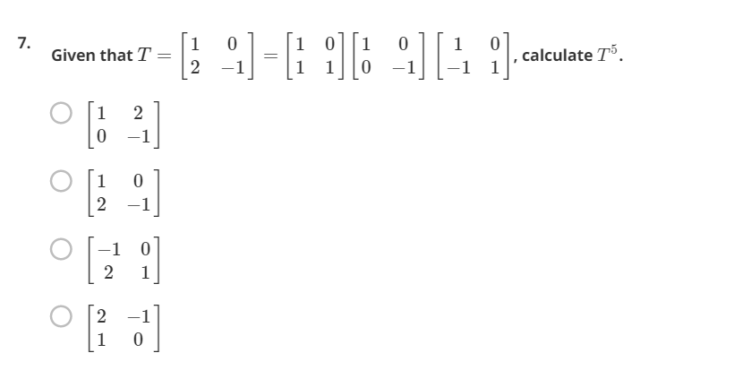

T5 = CD5C-1

Here D5 = D and Hence T5 = T =